EX1077

Nikhil Nandagopan

**WebApi Code**

GitRepo link: <https://github.com/nikhil2021experion/BookRentalAppProject>

**ScreenShots Of Api:**

**Books**

**https://localhost:44357/api/Books**

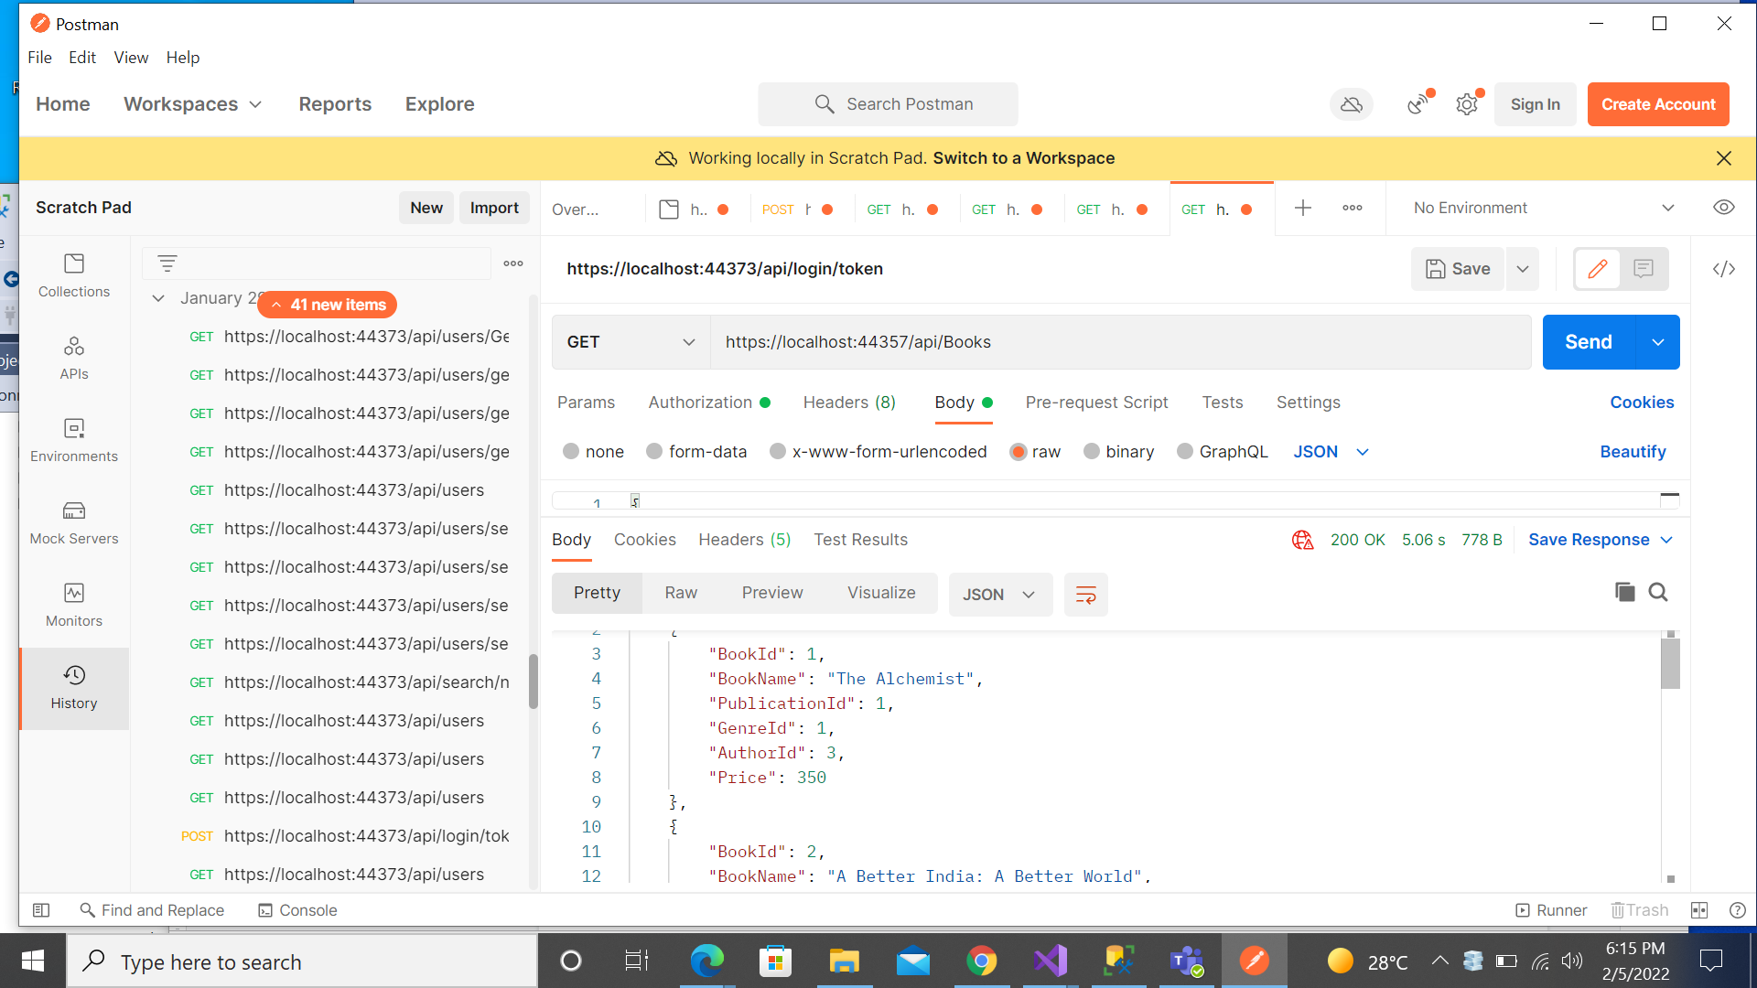

https://localhost:44357/api/Books

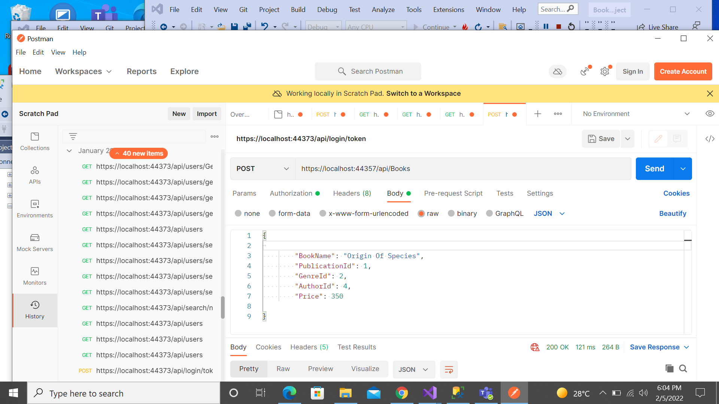

https://localhost:44357/api/Books/GetBooksById/1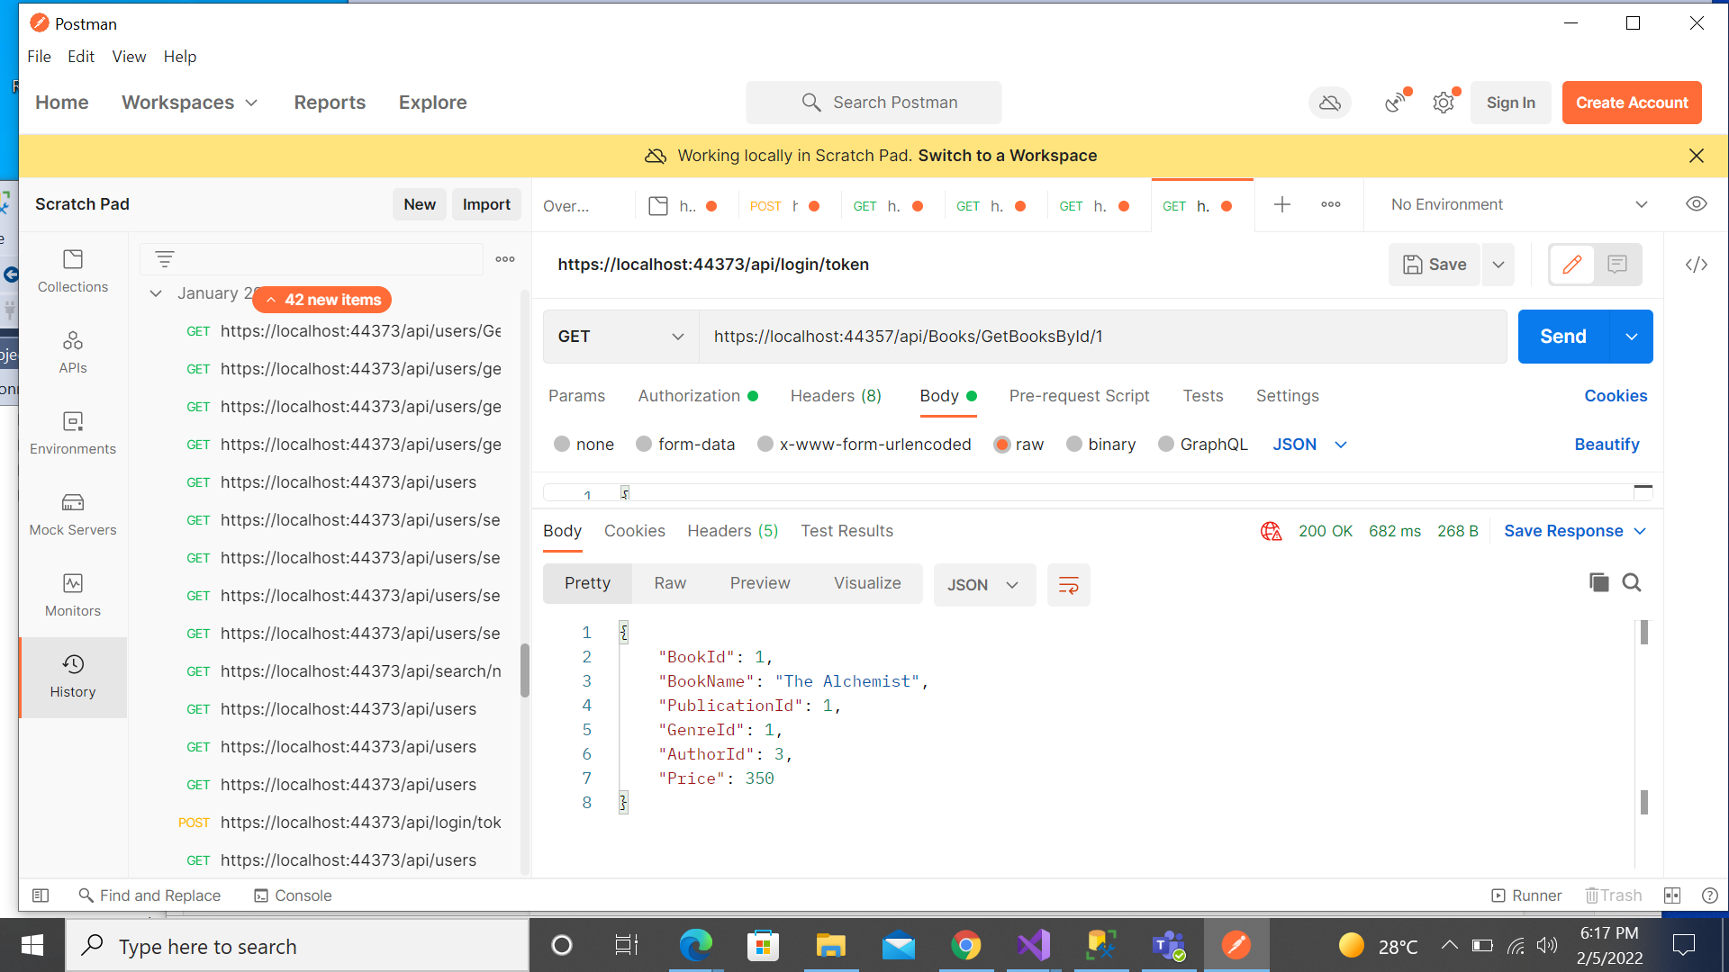

[https://localhost:44357/api/Books/6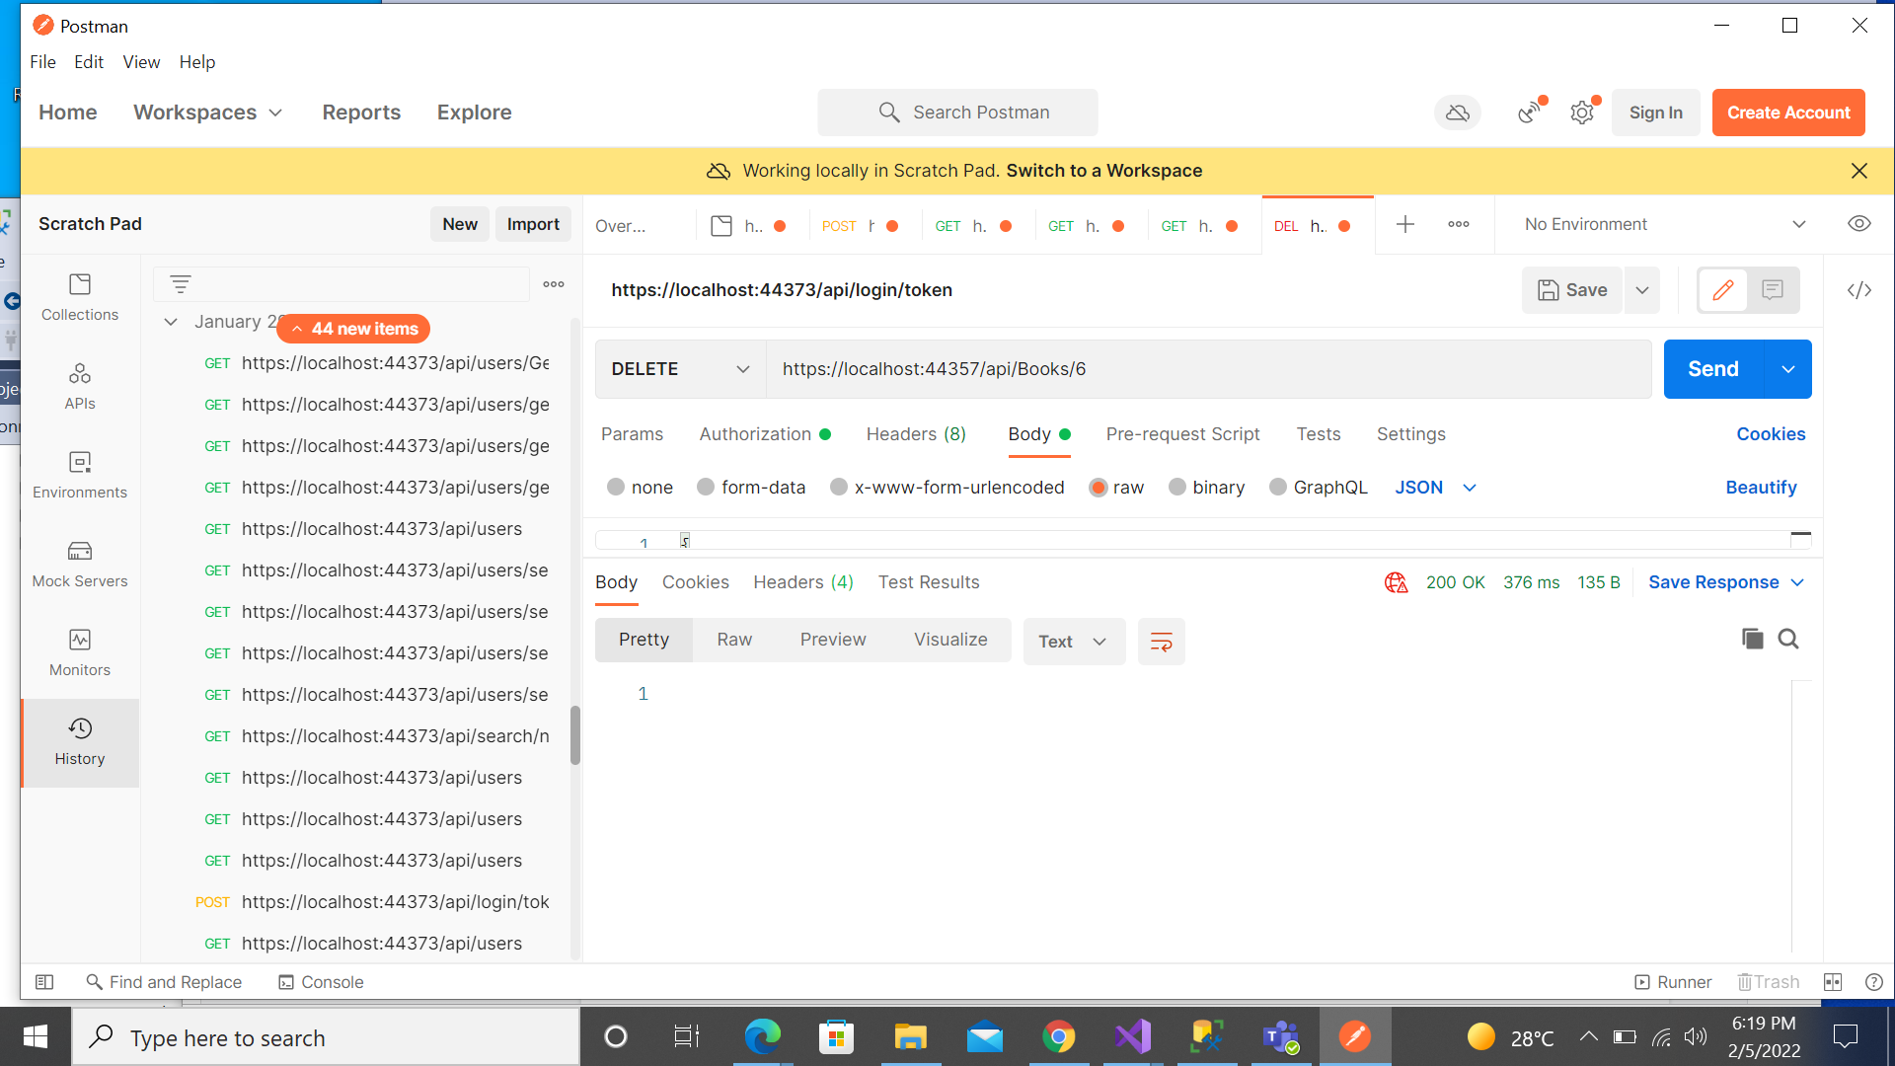](https://localhost:44357/api/Books/6*)

**Authors**

<https://localhost:44357/api/Authors>

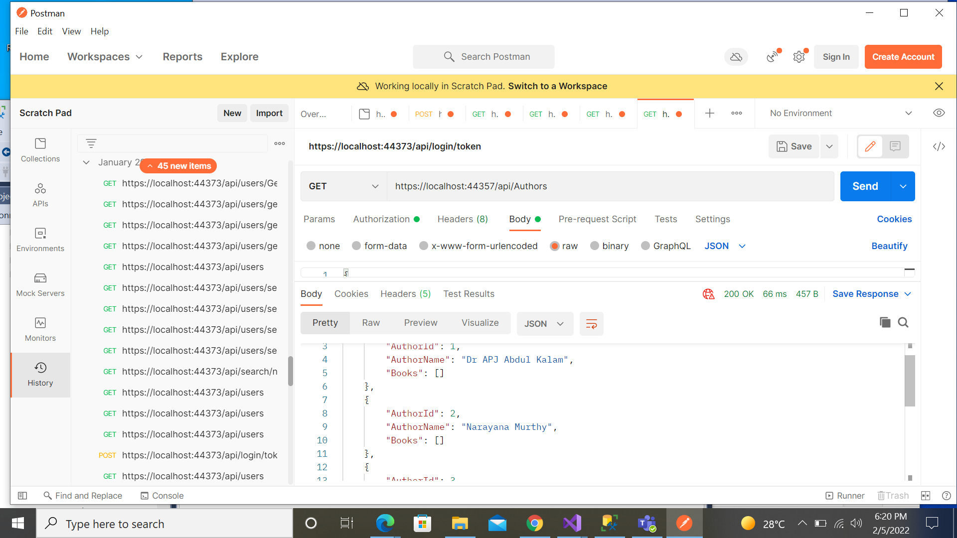

<https://localhost:44357/api/Authors>

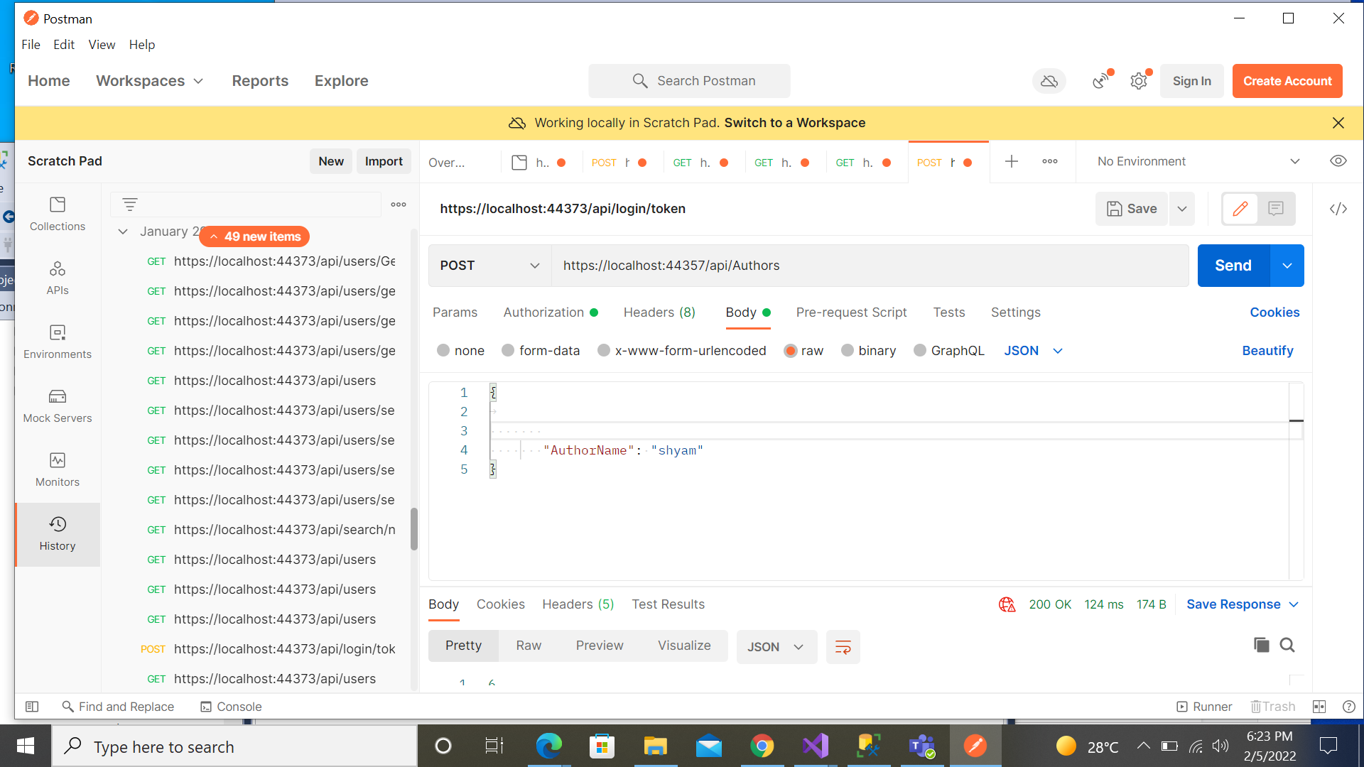

**Genres**

<https://localhost:44357/api/Genres>

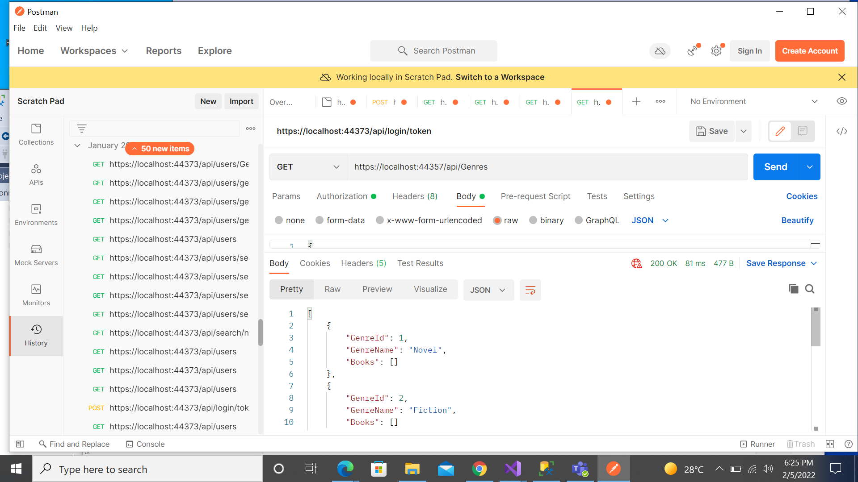

<https://localhost:44357/api/Genres/GetGenreById/1>

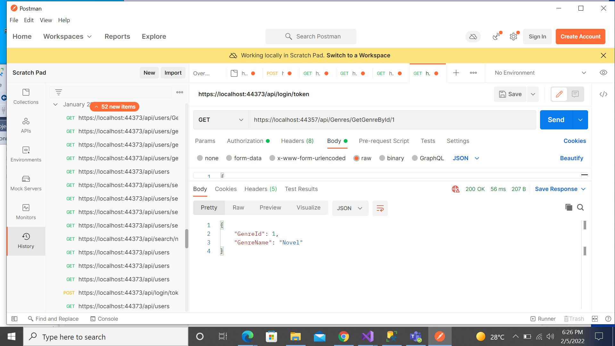

**Members**

<https://localhost:44357/api/Members>

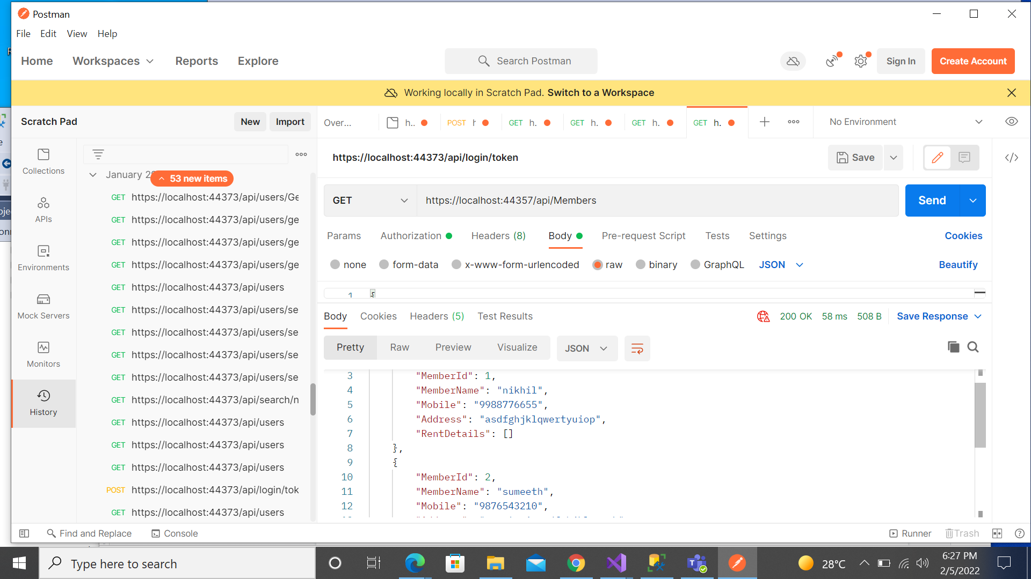

<https://localhost:44357/api/Members/GetMemberById/1>

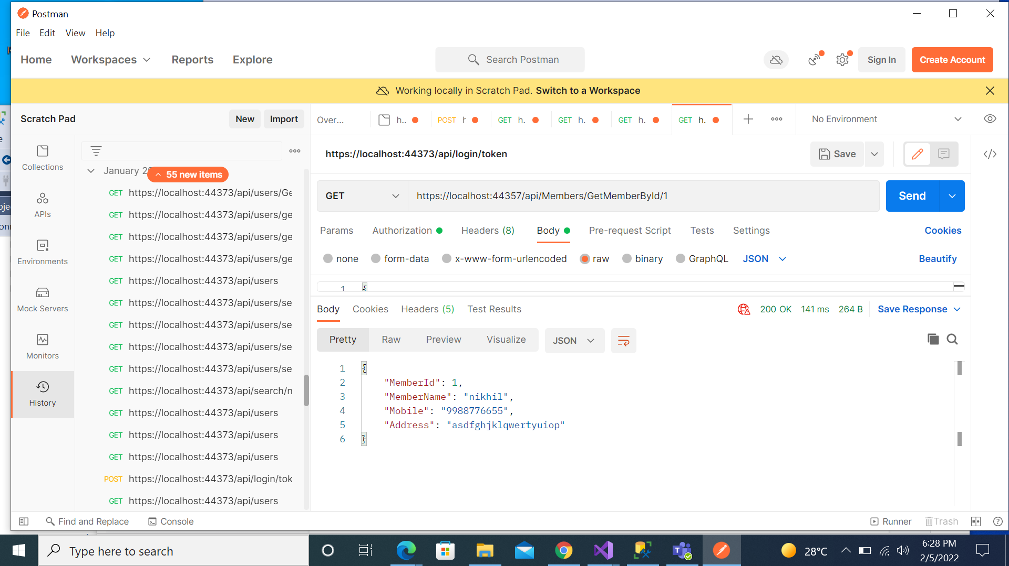

**1. List of books with book details, price and rental amount**

<https://localhost:44357/api/ListOfBooks>

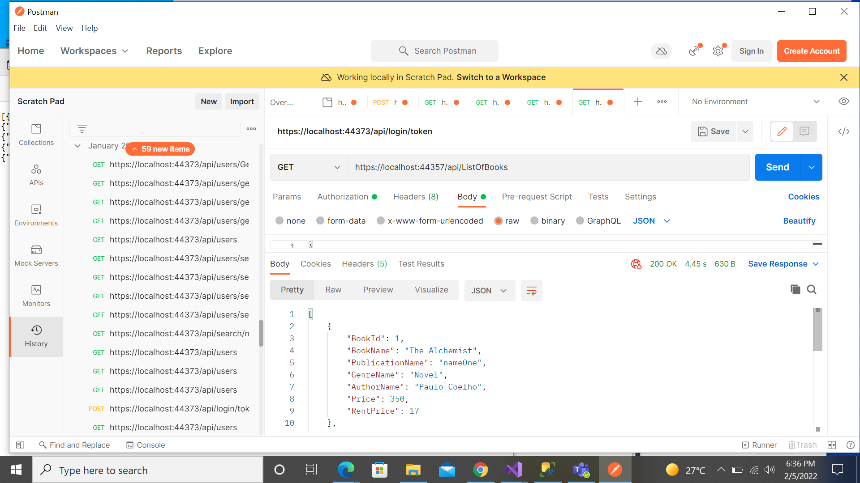

**JWT Token Creation**

<https://localhost:44357/api/login/token>

